Rising Waters: A Machine Learning Approach to Flood Prediction
Project Description
Rising Waters: A Machine Learning Approach to Flood Prediction is an intelligent web-based application that leverages machine learning techniques to predict the likelihood of flood occurrence using historical weather and rainfall data. The primary objective of the project is to support disaster preparedness by providing early flood risk predictions based on meteorological parameters such as temperature, humidity, cloud cover, annual rainfall, and seasonal rainfall.
The system employs multiple machine learning classification algorithms, including Decision Tree, Random Forest, K-Nearest Neighbors (KNN), and XGBoost, to analyze historical flood data and identify patterns associated with flood events. After evaluating the performance of each model using accuracy score, confusion matrix, and classification report, the best-performing model is selected and saved for deployment.
The trained model is integrated into a Flask-based web application, allowing users to enter weather and rainfall values through a simple interface and instantly receive a prediction indicating whether there is a Flood Chance or No Flood Chance. The application demonstrates the practical use of machine learning in environmental monitoring and disaster management while providing an accessible tool for early flood risk assessment.
By combining data analysis, machine learning, and web technologies, Rising Waters provides an effective decision-support system that contributes to improved disaster preparedness, better resource planning, and enhanced public safety.

Scenarios

Scenario 1: Disaster Management Authority
A disaster management officer receives updated rainfall and weather information for a particular region. The officer enters the meteorological parameters into the Rising Waters application. The trained machine learning model predicts a high probability of flooding, allowing authorities to issue early warnings, prepare evacuation plans, and allocate emergency resources before the disaster occurs.

Scenario 2: Meteorological Department
A weather analyst collects seasonal rainfall and climate observations from a region experiencing heavy rainfall. Using the Flood Prediction System, the analyst evaluates whether the current weather conditions indicate a potential flood event. The prediction assists in generating weather advisories and improving regional flood preparedness.

Scenario 3: Local Community Awareness
Residents living in flood-prone areas use the application by entering local weather observations such as temperature, humidity, cloud cover, and rainfall values. The application instantly predicts the flood risk, helping families take preventive measures to protect lives and property during periods of heavy rainfall.

Technical Architecture

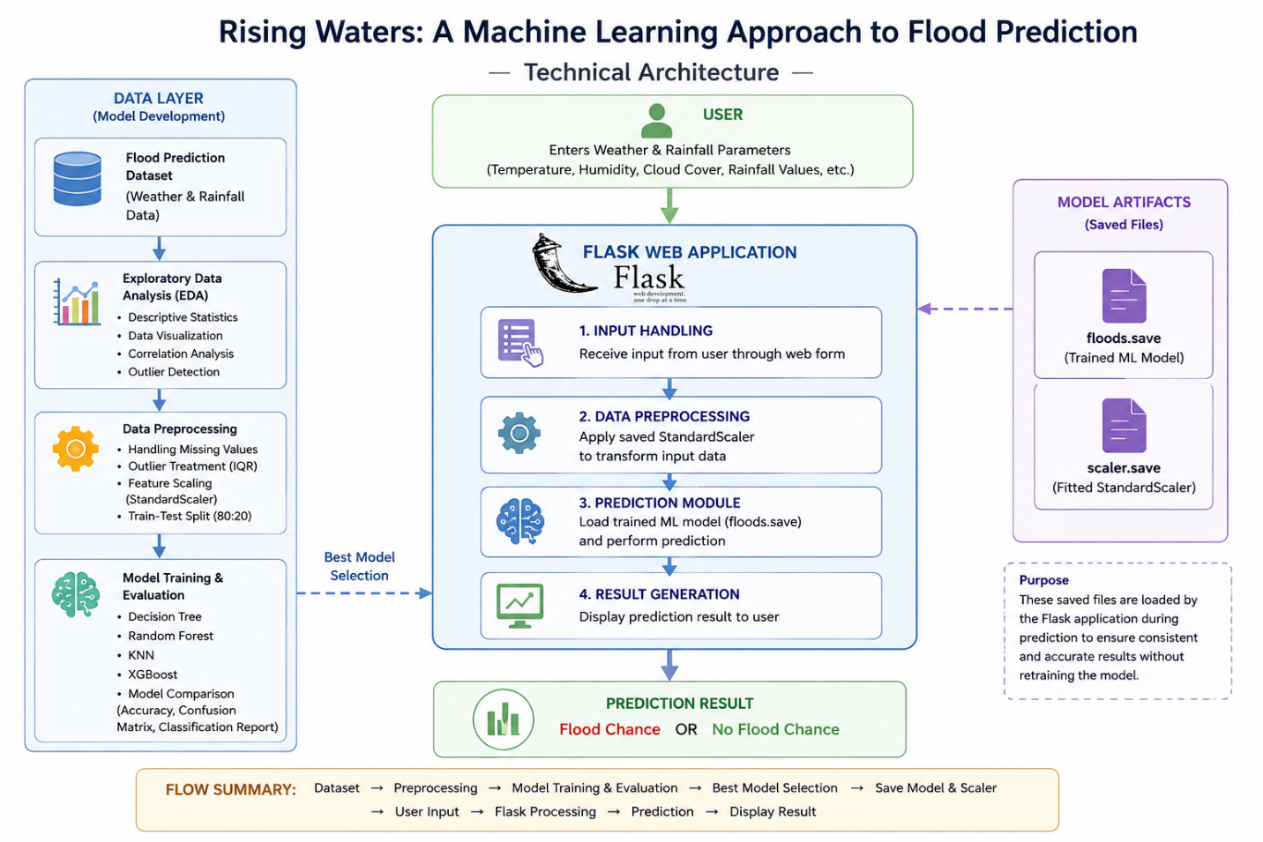

Description

The Rising Waters Flood Prediction System follows a modular three-tier architecture consisting of a user interface, a machine learning prediction layer, and a data processing layer.

The Frontend is developed using HTML and CSS, providing a user-friendly interface for entering weather and rainfall information. Users submit meteorological values through the prediction form.

The Backend is implemented using the Flask Framework, which receives user inputs, validates the data, loads the trained machine learning model (floods.save) and the saved feature scaler (scaler.save), performs feature scaling, and generates flood predictions.

The Machine Learning Layer contains the trained classification model developed using Scikit-learn and XGBoost. During model development, the dataset undergoes preprocessing, exploratory data analysis, feature scaling, and model evaluation. The best-performing model is serialized using Joblib and integrated into the Flask application for real-time predictions.

Prerequisites

Before developing the Rising Waters Flood Prediction System, ensure the following software and libraries are installed:
Programming Language
- Python 3.10 or above
Development Environment
- Anaconda Navigator
- Jupyter Notebook
- Visual Studio Code
Required Python Libraries
- NumPy
- Pandas
- Matplotlib
- Seaborn
- Scikit-learn
- XGBoost
- Flask
- Joblib
- OpenPyXL
Machine Learning Knowledge
Basic understanding of:
- Data Preprocessing
- Classification Algorithms
- Feature Scaling
- Model Evaluation
Web Development Knowledge
Basic knowledge of:
- HTML
- CSS
- Flask Framework

Project Workflow:

Milestone 1
Environment Setup
- Install Python and Anaconda.
- Install required libraries.
- Configure the development environment.
- Create the project directory.

Milestone 2
Dataset Collection
- Download the Flood Prediction Dataset.
- Load the dataset using Pandas.
- Verify dataset structure.
- Display dataset information.

Milestone 3
Exploratory Data Analysis
- Descriptive Statistics
- Univariate Analysis
- Multivariate Analysis
- Distribution Plots
- Box Plots
- Correlation Heatmap

Milestone 4: Data Preprocessing
This milestone focuses on preparing the flood prediction dataset for machine learning by cleaning the data, handling inconsistencies, detecting outliers, performing feature scaling, and dividing the dataset into training and testing subsets. Proper preprocessing improves model performance and ensures reliable flood predictions.

Activity 4.1: Handling Missing Values
Objective
Identify missing values in the dataset and apply appropriate treatment before training the machine learning models.
Steps
- Load the dataset using the Pandas library.
- Check for missing values using isnull().sum().
- If missing values are present, replace them with the median of the corresponding numerical column.
- Verify that the dataset contains no missing values after preprocessing.
Purpose
Handling missing values prevents errors during model training and ensures the dataset remains complete and consistent.

Activity 4.2: Detecting and Treating Outliers
Objective
Detect abnormal rainfall values that may negatively affect model performance.
Steps
- Calculate the First Quartile (Q1) and Third Quartile (Q3).
- Compute the Interquartile Range (IQR).
- Determine the lower and upper boundaries.
- Cap rainfall values outside these boundaries using NumPy.
Purpose
Outlier treatment reduces the influence of extreme rainfall observations while preserving the dataset.

Activity 4.3: Splitting Features and Target Variable
Objective
Separate the dataset into input features and the target variable.
Input Features
- Temperature
- Humidity
- Cloud Cover
- Annual Rainfall
- Jan–Feb Rainfall
- Mar–May Rainfall
- Jun–Sep Rainfall
- Oct–Dec Rainfall
- Average June Rainfall
- Sub Rainfall
Target Variable
- Flood (0 = No Flood, 1 = Flood)

Activity 4.4: Train-Test Split
Objective
Split the dataset into training and testing subsets.
Configuration
- Training Data: 80%
- Testing Data: 20%
- Random State: 42
- Stratified Sampling: Enabled
Purpose
The training dataset is used to build machine learning models, while the testing dataset evaluates model performance using unseen data.

Activity 4.5: Feature Scaling
Objective
Normalize numerical features before training distance-based machine learning algorithms.
Steps
- Initialize the StandardScaler.
- Fit the scaler using the training dataset.
- Transform both training and testing datasets.
- Save the scaler using Joblib for deployment.
Purpose
Feature scaling ensures that all variables contribute equally during model training and improves prediction accuracy.

Milestone 5: Model Building
This milestone involves training multiple machine learning classification algorithms and comparing their prediction performance using the prepared dataset.

Activity 5.1: Decision Tree Classifier
Objective
Train a Decision Tree classifier to classify flood and non-flood conditions.
Steps
- Import the Decision Tree classifier.
- Train the model using the scaled training dataset.
- Predict the testing dataset.
- Evaluate using:
  - Accuracy Score
  - Confusion Matrix
  - Classification Report

Activity 5.2: Random Forest Classifier
Objective
Improve prediction performance by combining multiple decision trees.
Steps
- Import the Random Forest classifier.
- Train using the training dataset.
- Predict flood occurrence.
- Evaluate using standard classification metrics.

Activity 5.3: K-Nearest Neighbors (KNN)
Objective
Predict flood occurrence based on the nearest neighboring observations.
Steps
- Select an appropriate value of K.
- Train the KNN classifier.
- Predict the testing dataset.
- Measure prediction accuracy.

Activity 5.4: XGBoost Classifier
Objective
Train an advanced gradient boosting model capable of achieving higher prediction accuracy.
Steps
- Import the XGBoost classifier.
- Train using the scaled dataset.
- Predict flood occurrence.
- Evaluate performance.
Purpose
XGBoost generally provides superior prediction performance due to gradient boosting and regularization techniques.

Milestone 6: Model Evaluation
This milestone evaluates all trained machine learning models and identifies the most accurate model for deployment.

Activity 6.1: Performance Evaluation
Evaluate every model using:
- Accuracy Score
- Confusion Matrix
- Classification Report
Activity 6.2: Model Comparison
Create a comparison table containing:
Model | Accuracy
Decision Tree | 0.956522
Random Forest | 0.956522
KNN | 0.869565
XGBoost | 0.869565

Activity 6.3: Accuracy Visualization
Plot a bar chart comparing the accuracy of all trained models.
Purpose:
- Easy comparison
- Better visualization
- Supports model selection

Activity 6.4: Best Model Selection
Compare all models and select the classifier with the highest accuracy.
The selected model is saved using Joblib.
Saved Files:
floods.save
scaler.save
These files are later used by the Flask application to make predictions without retraining the model.

Milestone 7: Flask Web Application Development
This milestone integrates the trained machine learning model into a Flask-based web application, enabling users to predict flood risk through a graphical interface.

Activity 7.1: Project Structure
Create the project folders:
Flood_Prediction/
│
├── app.py
├── floods.save
├── scaler.save
├── requirements.txt
│
├── templates/
│ ├── home.html
│ ├── predict.html
│ └── result.html
│
└── static/
└── style.css

Activity 7.2: Backend Development
Develop the Flask application (app.py) to:
- Load the trained model.
- Load the saved scaler.
- Accept user input.
- Perform feature scaling.
- Predict flood occurrence.
- Display prediction results.

Activity 7.3: Frontend Development
Develop three HTML pages:
Home Page
Displays:
- Project Title
- Project Description
- Start Prediction Button
Prediction Page
Allows users to enter:
- Temperature
- Humidity
- Cloud Cover
- Annual Rainfall
- Seasonal Rainfall Values
- Average June Rainfall
- Sub Rainfall
Result Page
Displays:
- Flood Chance
or
- No Flood Chance

Milestone 8: Deployment and Execution

Activity 8.1: Saving the Trained Model

Objective

Store the best-performing machine learning model and feature scaler for future predictions without retraining.

Steps

Select the best-performing model after evaluation.

Save the trained model using the Joblib library.

Save the fitted StandardScaler object.

Output Files

floods.save
scaler.save

Purpose

Saving the model and scaler allows the Flask application to load them directly and perform predictions efficiently.

Activity 8.2: Running the Flask Application

Objective

Deploy the flood prediction system locally using Flask.

Steps

Open the project folder in Visual Studio Code.

Open the integrated terminal.

Run the application using:

python app.py

Flask starts the local server.

Example:

* Running on http://127.0.0.1:5000

Open the URL in a web browser.

Purpose

This enables users to access the Flood Prediction System through a browser.

Milestone 9: Website Pages

The Flask application consists of three user-friendly web pages.

9.1 Home Page

Description

The Home Page welcomes users to the Flood Prediction System and provides a brief introduction to the project.

Features

Project Title

Project Description

Start Prediction Button

Purpose

Provides users with an overview of the application and allows navigation to the prediction page.

9.2 Prediction Page

Description

The Prediction Page contains an input form where users enter weather and rainfall values.

Input Parameters

Temperature

Humidity

Cloud Cover

Annual Rainfall

January–February Rainfall

March–May Rainfall

June–September Rainfall

October–December Rainfall

Average June Rainfall

Sub Rainfall

Purpose

Collects meteorological information required by the machine learning model to predict flood occurrence.

9.3 Result Page

Description

After submitting the form, the application processes the inputs and displays the prediction.

Possible Outputs

Flood Chance Detected

No Flood Chance

Purpose

Provides users with an immediate prediction based on the trained machine learning model.

System Workflow

Historical Flood Dataset
│
▼
Data Preprocessing
│
▼
Exploratory Data Analysis
│
▼
Feature Scaling
│
▼
Machine Learning Models
(Decision Tree, Random Forest,
KNN, XGBoost)
│
▼
Best Model Selection
│
▼
Save Model (floods.save)
│
▼
Flask Web Application
│
▼
User Inputs Weather Data
│
▼
Prediction
│
▼
Flood / No Flood Result

Advantages

The Rising Waters Flood Prediction System provides several benefits:

Early identification of potential flood events.

Supports disaster preparedness and emergency planning.

Helps authorities issue timely warnings.

Simple and user-friendly web interface.

Fast prediction using a trained machine learning model.

Reduces manual analysis of weather data.

Easily extendable with larger datasets.

Can assist researchers and disaster management agencies.

Applications

The Flood Prediction System can be used in:

Disaster Management Authorities

Meteorological Departments

State and District Administration

Environmental Research Organizations

Smart City Projects

Agricultural Planning

Flood Monitoring Centers

Educational Institutions for research

Limitations

Although effective, the current implementation has certain limitations:

Predictions depend on the quality of historical data.

The model does not use real-time weather information.

The dataset size is relatively small.

Predictions are limited to the available meteorological features.

The system currently performs binary classification (Flood / No Flood).

Future Scope

The project can be enhanced by incorporating additional features and technologies.

Possible future improvements include:

Integration with real-time weather APIs.

Live rainfall monitoring.

GIS-based flood risk mapping.

Mobile application development.

SMS and email alert systems.

IoT sensor integration.

Deep Learning models such as LSTM for time-series forecasting.

Cloud deployment using IBM Cloud, AWS, or Microsoft Azure.

Interactive dashboards for disaster management authorities.

Conclusion

Flood prediction plays a crucial role in minimizing the impact of natural disasters by enabling timely preparedness and effective decision-making. The Rising Waters: A Machine Learning Approach to Flood Prediction project demonstrates how machine learning can be applied to analyze historical weather and rainfall data for predicting flood occurrence.

The project successfully implemented a complete machine learning pipeline, including data collection, exploratory data analysis, preprocessing, model training, evaluation, and deployment. Multiple classification algorithms—Decision Tree, Random Forest, K-Nearest Neighbors (KNN), and XGBoost—were trained and compared to identify the most effective model. The selected model was integrated into a Flask-based web application, allowing users to enter weather and rainfall information and receive instant flood predictions.

This project highlights the practical application of data science and web development in disaster management. It provides a reliable and user-friendly system that can support early warning initiatives, improve emergency planning, and contribute to protecting lives and property. With future enhancements such as real-time weather integration and cloud deployment, the system can be further developed into a comprehensive flood monitoring and decision-support platform.

References

Scikit-learn Documentation – https://scikit-learn.org

XGBoost Documentation – https://xgboost.readthedocs.io

Flask Documentation – https://flask.palletsprojects.com

Pandas Documentation – https://pandas.pydata.org

NumPy Documentation – https://numpy.org

Matplotlib Documentation – https://matplotlib.org

Seaborn Documentation – https://seaborn.pydata.org

Kaggle Flood Prediction Dataset – https://www.kaggle.com

